# 

## CUSTOMER MASTER

## https://lh6.googleusercontent.com/6VXJnC62fcxOOhk0IYx4f7J7UVTCKGhdEBX8PKogaZlT7_uq7EJGrG400kqWqPxpbjSwRA-6vXGak0Pst2yWt4d7a60M008i42S5xhYeFmAmX4WFFgKq3ujnGUiQMb7-Gw9sR2qC

**ACCOUNT MASTER**

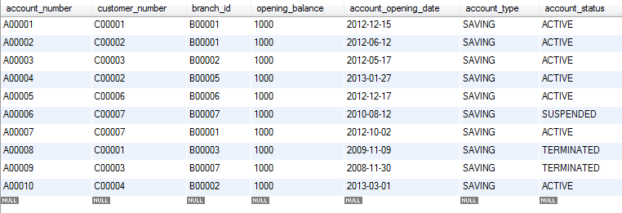

**BRANCH MASTER**

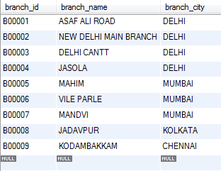

**LOAN DETAILS**  
  
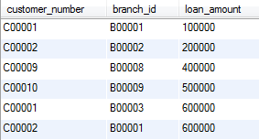

**TRANSACTION DETAILS**

